**DO NOT SKIP - I Would Love To Congratulate You!**

You're doing an incredible job! Keep that momentum going strong.

Completing an online course is no small feat, and you're accomplishing something truly remarkable.

**CONGRATULATIONS!** Keep up the great work, and happy learning!

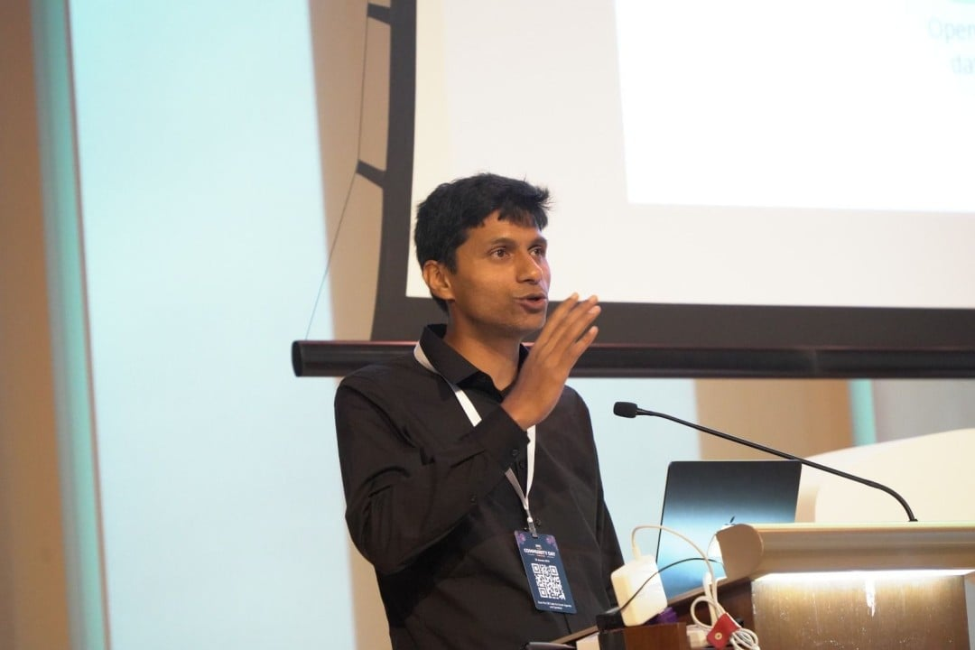

Best Regards,  
Ranga